FACT SHEET: “No Wars, No Warming”- How Do We Get There?
The Coalition for Peace Action actively supports the end of nuclear weapons. We also support building a worldwide Green Peace Economy, to save the planet from climate catastrophe, and from wars for access to water and resources, in the decades to come. Thus, we have a “No Wars, No Warming” campaign. The global Climate Strikes in 2019 and 2020, and growing climate solutions movements as we reach the 50th Anniversary of Earth Day, show that this issue is top of mind for many people, and urgently so, as weather extremes are recorded, from California’s wildfires, to the Mississippi River, to flooding from the East Coast’s rising seas and in Western Europe-- not to mention Pacific typhoons.
As the Trump administration undermines EPA at home, and the limited progress of the 2015 Paris Climate Accords globally, it’s time to get even more serious about No Wars, No Warming. We support both the idea of a Green Peace Economy, and a remarkable blueprint for conquering both global climate crisis and nuclear dangers, called Warheads to Windmills. It starts with adding the US to nations working toward new Paris II goals. What this means is-- Investing in the future, solar, wind, and wave energy, and not the past-- fossil fuels and nukes.
How are nuclear weapons and climate change related?
Nuclear weapons and climate change are both existential threats to the future of life on earth. Nuclear weapons are also a climate issue themselves. In a nuclear war, as much as 150 million tons of soot could be blasted into the upper atmosphere. This could lower global temperatures by as much as 7 degrees C (or 12 degrees F) for an extended period of time, plunging major food-producing regions of the world to below-freezing temperatures for years. Even a “limited” nuclear war could lower global temperatures enough to starve more than 2 billion people. Meanwhile, the Pentagon is the world’s single biggest fossil fuel polluter- this must end, and that is a prime goal.
Unfortunately, the two potential climate catastrophes do not cancel each other out. But we can use one to solve the other, if we move to abolish nuclear weapons and shift the funding, brainpower, and infrastructure to green technologies. And this can be done, by combining two profound solutions: the Nuclear Ban Treaty and a Green Peace Economy — swiftly, before it’s too late. Here is a roadmap to get there.
1. Transfer funds from nukes and military, to Green Economy.
Right now, we’re wasting $55 Billion + a year on “modernization” (escalation) of nukes. Over 20 years, we can save $2 Trillion, and put our investment in the future-- a Green Peace Economy.
2. Redirect STEM Talent. We need experts currently employed building nuclear weapons to tackle the climate crisis. To implement a Green Peace Economy, we need scientific, technical, engineering, and mathematical (STEM) expertise to solve the remaining challenges of sustainable energy generation, storage, and transport, and use. Yet in 2016, 5 out of 10 STEM graduates went to work with companies that design, build and maintain nuclear and other weapons. And, we have many well-trained, but currently underemployed auto workers, for the new electric car industry. The maps below show what a difference this will make in well-paying U.S. industrial jobs.
3. From a Budding Cold War, to International Cooperation.
The United States, China, Russia and India account for more than half of the world’s total carbon emissions. Together with the other five nuclear-armed nations and their nuclear allies, these countries collectively emit nearly three quarters of all the world’s greenhouse gases. Imagine if we turned these talents and resources to solving climate change. Let’s talk, not confront-- it’s an international Win-Win, not Zero-Sum as now.
Nuclear Jobs Now vs. Jobs in the Green Peace Economy:
See the comparative maps on page two- they help counter the myth that a Green Economy loses jobs. Rather, we will gain as much as a million jobs a year, if we move to invest in the Green Economy’s potential this decade.
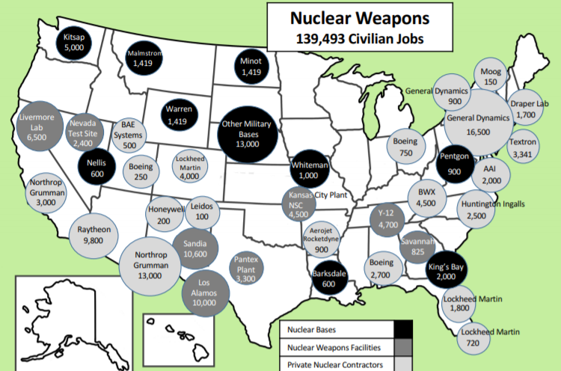
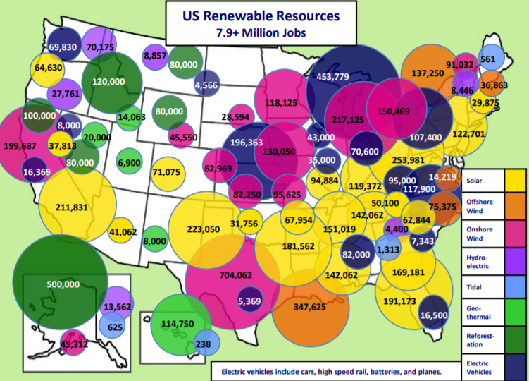
Source: nuclearban.us 2019. Renewable Energy Jobs by 2030, by Timmon Wallis.
We are CFPA-- Join us! To join our efforts, or to find our coming events, go to: www.Peacecoalition.org, contact nikivanaller@peacecoalition.org. Our thanks in particular to Timmon Wallis, who did much research underlying this summary; and to TheSolutionsProject.org at Stanford University, led by Prof. Mark Z. Jacobsen, who notes that in Philadelphia alone, for example, we can add over 36,000 well-paid jobs in green motor vehicle production-- these should be focused as much as possible in the inner city, as a way to build wealth in our communities. The Solutions Project also provides grants for female- and minority-led, community-based climate initiatives. More on NO WARS, NO WARMING, at Peacecoalition.org, the CFPA Web site.

